**HAPPE+ER’s generateERPs Add-On User Guide**

**Run generateERPs:**

1. If ignoring bad channels, create the bad channels spreadsheet.
   * For detailed instructions, read through the following command line prompts section.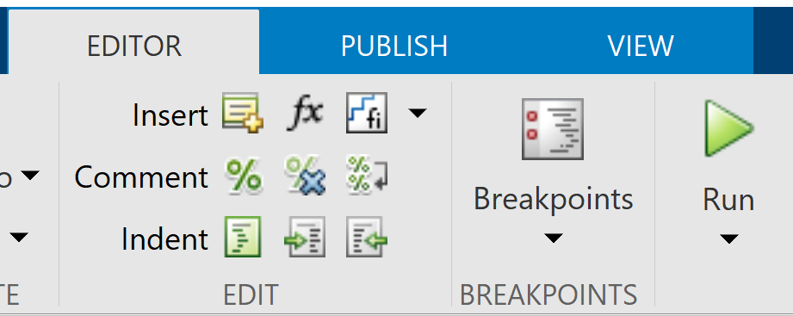
2. Navigate to the main HAPPE folder in your file browser.
3. Open generateERPs.m in MATLAB.
4. In the Editor tab, hit “Run.”
5. Follow the prompts in the command window of MATLAB
   * For detailed instructions regarding the prompts, see below.

**Following Command Line Prompts:**

Prompts as they appear in the command window are written in Courier New, like this, followed by a brief description of what to enter, with an example, also in Courier New. Sometimes a certain choice will result in a different set of prompts - in which case they will be indented under a heading that describes the choice needed for them to appear.

Preparing HAPPE - ERP ADD-ON...

Enter the path to the folder containing the processed dataset(s):

This is requesting the folder where your processed data is stored. In most cases, this is the “5 - processed” folder created during the HAPPE run. If you enter a non-existent path, you will be prompted to re-enter the correct path. Please note that whether you use a backslash or a forward-slash depends on your operating system (e.g., Mac vs Windows).

**Example (Mac):** /Users/laurelg-d/Desktop/Data Folder/5 - processed

**Example (Windows):** C:\Users\laurelg-d\Documents\Data Folder\5 - processed

Enter the suffix used for this dataset, including stimulus tag (if applicable).

If no extension beyond "AveOverTrials", press enter/return.

Files created by HAPPE as a default are named *filename_processed_AveOverTrials*. In the case of a re-run, they may have additional text following “AveOverTrials”, for example, *filename_processed_*

*AveOverTrials_rerun2021*. If there is additional text, enter all the text that follows “AveOverTrials.” In this example, you would enter “_rerun2021” without the quotations. If there is no additional text, you can simply hit your newline key - “enter” on Windows keyboards and “return” on Mac keyboards. Regardless of additional text follows “AveOverTrials”, you do not need to include “.txt”.

**Example:** _VEP1

Examine all channels (all) or only channels of interest (coi)?

This question is asking about which channels/electrodes should be included in the ERP. To select all channels present in the dataset, enter all. To select a subset of channels, O1 and O2 for example, enter coi. If you choose to only examine channels of interest, you must follow some additional prompts (see below).

These prompts only appear if you have selected to filter to a set of channels of interest:

Choose an option for entering channels:

include - Include ONLY the entered channel names.

exclude - Include every channel EXCEPT the entered channel names.

Choose whether the channels you enter will be the channels of interest or the channels of

disinterest. If you select include, the channel names you enter in the following prompt will be the only channels included in the ERP. If you select exclude, the channels you enter will be the only ones not included in the ERP.

Enter channels, including the preceding letter, one at a time.

Press enter/return between each entry.

Examples: E17

M1

When you have entered all channels, input "done" (without quotations).

Enter the channels you wish to include/exclude in your ERP one at a time. You should include the preceding letter, if applicable. If you have any questions about your channel names, refer to your acquisition layout. If the 10-20 channel locations are present and named accordingly in your dataset, use those names where applicable (e.g., use O1 instead of E70 for EGI GSN HydroCel 128 layouts). Between each entry, press your newline key (enter - Windows, return - Mac). When you are done entering channels, enter done.

Include bad channels in calculating ERP?

include = keep bad channels

exclude = remove bad channels

During HAPPE+ER’s processing, bad channels may have been detected in the dataset. If bad channels were detected, you can choose whether to include these channels (in the case that they were interpolated) or exclude them from the ERP. If you decide to exclude the bad channels, you will need to follow additional prompts (see below).

These prompts only appear if you have selected to exclude bad channels from the ERPs:

Enter the file containing the bad channels, including the complete path.

Refer to the HAPPE User Guide for instructions on creating this file and an example.

Prior to running the generateERPs script, you should make a spreadsheet (.xlsx, .csv, etc.) containing a list of the files and the bad channels associated with each file. The easiest way to do this is to copy the first column (labeled “Row”) and the “Interpolated_Channel_IDs” column from the HAPPE_dataQC output created at the time the data was processed and create a new spreadsheet using those. Make sure to remove any rows for data you are not examining.

**Example:**

|  |  |
| --- | --- |
| Data File Name | Bad Channels |
| file01.raw | F3 F4 T6 CZ E31 |
| file02.raw | T6 O1 O2 P3 P4 CZ E6 |

For this prompt, enter the path to where the spreadsheet is saved followed by a slash (forward-slash or backslash depends on your OS) and the name of the spreadsheet, including the file extension (e.g., .csv).

**Example (Mac):** /Users/laurelg-d/Documents/badChannels.csv

**Example (Windows):** C:\Users\laurelg-d\Documents\badChannels.csv

Calculate ERP values? [Y/N]

This script has the capability to calculate values commonly associated with ERPs, such as peak amplitudes and their latency, and area under the curve. If interested in calculating these values, enter y; otherwise, enter n; selection is case-insensitive. Selecting to calculate ERP values will require following additional prompts (see below).

These prompts only appear if you have selected to calculate ERP values:

Enter latency windows of interest with anticipated peak:

Enter each window as two consecutive numbers followed by "max" or "min" (without quotations).

Press Enter/Return between entries.

When you have entered all windows, input "done" (without quotations).

Example: 10 100 max

Enter your latency periods as two consecutive numbers, with the first number representing the starting latency for your window and the second as the ending latency for your window. Try to use latencies that are included as points in your data or the script will correct your boundaries to the closest latency that exists in your data. Windows are also not allowed to include a negative latency value.

For each window you must also specify whether you anticipate to find a maximum or a minimum amplitude in the provided. You can do so by including max or min, respectively, following the two numbers representing the window’s boundaries. If you want to look for both a maximum and a minimum within the same window, you must enter the latency window twice and alternate specifying max and min.

**Example:** 10 100 min

Choose a method for calculating area under the curve:

windows = restrict calculations to the specified latency window

zeros = calculate area under the curve using points where the amplitude = 0

both = calculate both by windows and by zeros

You can choose whether to calculate area under the curve using the windows you specified as bounds, using zero crossings present in the dataset as bounds, or using both methods. Choosing windows restricts all area under the curve calculations to only the latency windows you specified previously. Choosing zeros allows the script to find the zero-crossings in the dataset and use those points as boundaries to create new windows in which to calculate the area under the curve.

**Errors:**

If at any point, generateERPs is unable to create the ERP or calculate values for a particular file, it will print out “Error in file FILENAME” to the command line and proceed to the next file.